The Goal
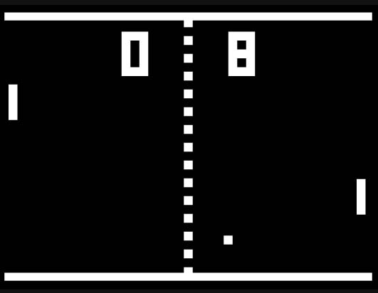
Your task for this assignment is to build a game called Pong.
If you don’t know Pong, its classic version looks like the image shown on the right here. Two players control a paddle each to bounce a ball back and forth. If you miss a ball, the other player gets a point.

The base tasks
The base tasks are those parts of the assignment that everyone is expected to complete. Here is what they are – your game should at least do this:
- This is a two-player game. One player controls one paddle with the ‘w’/’s’ keys, the other player controls the other paddle with the up/down cursor keys. The paddles move up and down.
- The ball moves at constant speed. It starts moving some short time after the game is started.
- The ball bounces off the paddles. It also bounces off the top and bottom edges of the screen.
- If the ball reaches the left or right sides of the screen, a player gets a point. The ball starts again (after a short delay) in the middle of the field.
- The game ends when one player has 8 points.
Note that the base tasks do not include displaying the score on screen.

Challenge tasks
There are many additional improvements that you can make to your game.
For example:
- Display the scores on screen.
- Use different images
- Put in sound.
- Use an opening screen with an image and maybe some instructions.
- Display a game-over image when the game is over. And a sound.
- Introduce random challenges. (Goodies, difficulty, speed, etc…)
- Many more things that you can invent yourself...

Grading
The submission will be marked for
- completeness (has all the required functionality been implemented?)
- correctness (does everything work as specified?)
- explanation of code (did you write it and do you understand it?)
- commenting (is everything commented as it should?)
- style (is the code nicely laid out and formatted, are the variable and method names chosen well?)
- difficulty (are any challenge tasks included?)
A submission with a perfect implementation of the base tasks will receive a good grade. To get a very good grade, you need to work on some challenge tasks as well.
Note: Think about the size of your world! We want this to be played on different types of devices at different resolutions. What looks good on a 27” monitor won’t fit on many other devices.

